**Batch: C2-2 Roll No.: 16010122109**

**Experiment / assignment / tutorial No. 1**

**Grade: AA / AB / BB / BC / CC / CD /DD**

**Signature of the Staff In-charge with date**

|  |
| --- |
| **TITLE:** Write a program for:  a. Program to find area and circumference of various Geometric shapes.  b. Program to calculate EMI (Equated Monthly Instalment) of loan amount if principal, rate of interest and time in years is given by the user.  (E = (P.r.(1+r)n) / ((1+r)n – 1) |

**AIM:** Write a program for:

a. Program to find area and circumference of various Geometric shapes.

b. Program to calculate EMI (Equated Monthly Instalment) of loan amount if principal, rate of interest and time in years is given by the user.

E = (P.r.(1+r)n) / ((1+r)n – 1)

**____________________________________________________________**

**Expected OUTCOME of Experiment:**

Formulate a problem statement and develop the logic (algorithm/flowchart ) for its solution.

**_____________________________________________________________________**

**Books/ Journals/ Websites referred:**

1. Programming in ANSI C, E. Balagurusamy, 7 th Edition, 2016, McGraw-Hill Education, India.
2. Structured Programming Approach, Pradeep Dey and Manas Ghosh, 1 st Edition, 2016, Oxford University Press, India.
3. Let Us C, Yashwant Kanetkar, 15th Edition, 2016, BPB Publications, India.

**_____________________________________________________________________**

**Problem Definition:**

Problem 1 : Area and Circumference of any shape(**will be given by instructor**) (example Circle)

Ask the user to enter the value of the radius of a circle.  Put the values in the formula for finding area of a circle and circumference of a circle and print the outcome for area of a circle and circumference of a circle

Problem 2: Calculating EMI

Ask the user to enter the value of principal amount, rate of interest and time (in years).Store the value in E and print the final monthly instalment E as an outcome.

Formula to be used: (E = (P.r.(1+r)n) / ((1+r)n – 1)

**Flowchart:**

* 1. ] Area and circumference of circle:

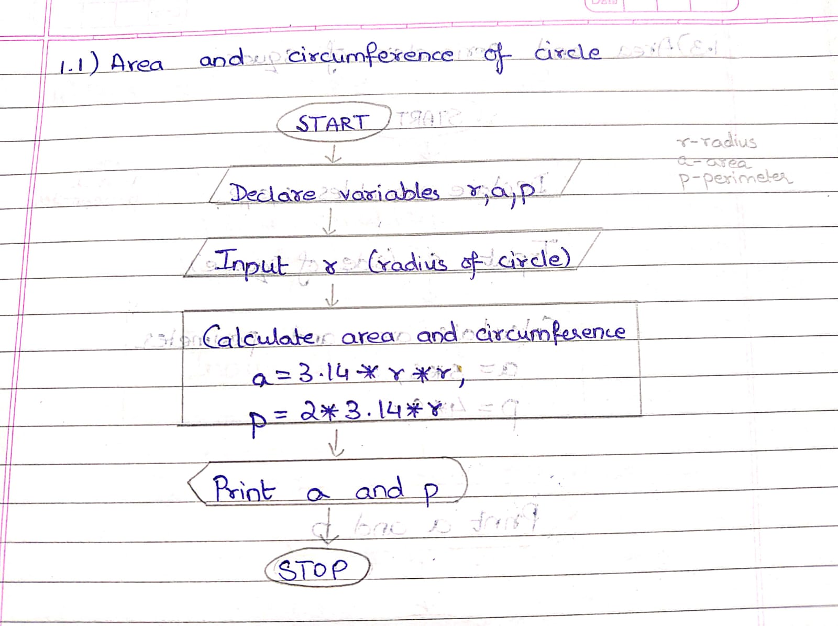

* 1. ] Area and perimeter of rectangle:

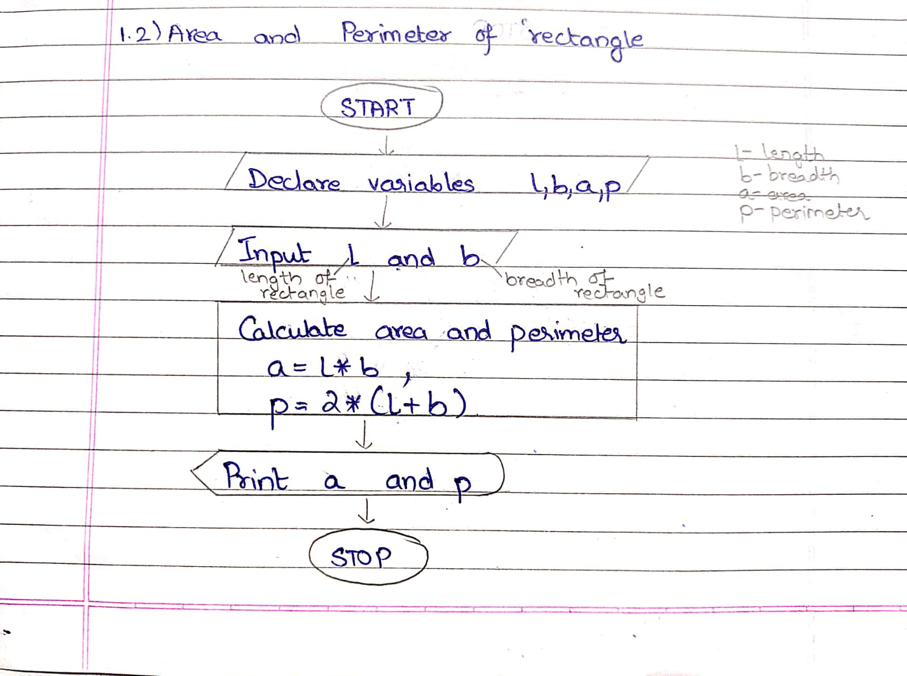

* 1. ] Area and perimeter of square:

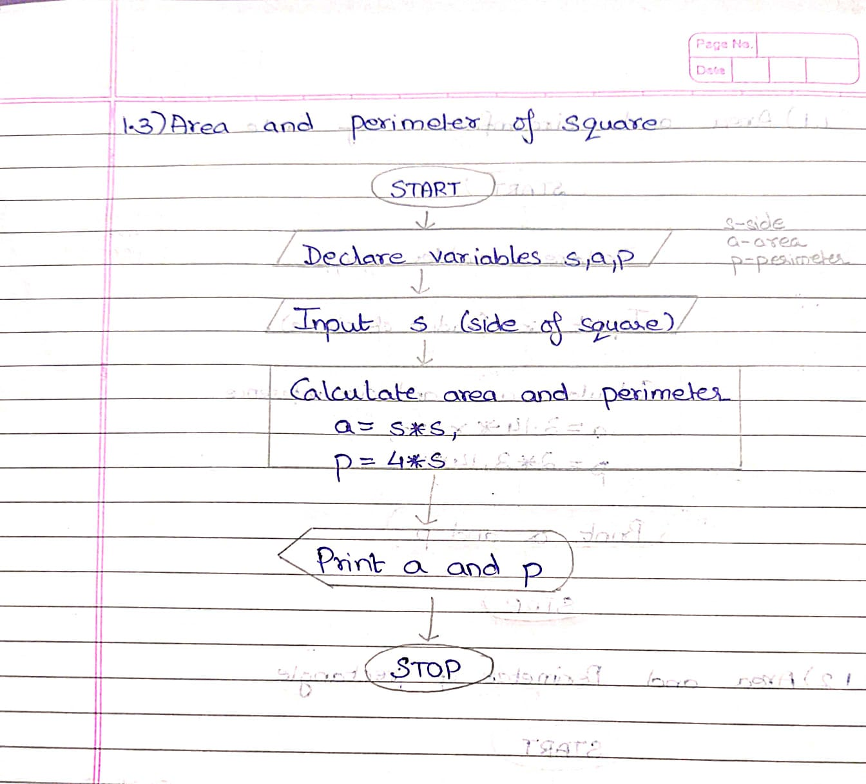

* 1. ] Area and perimeter of square:

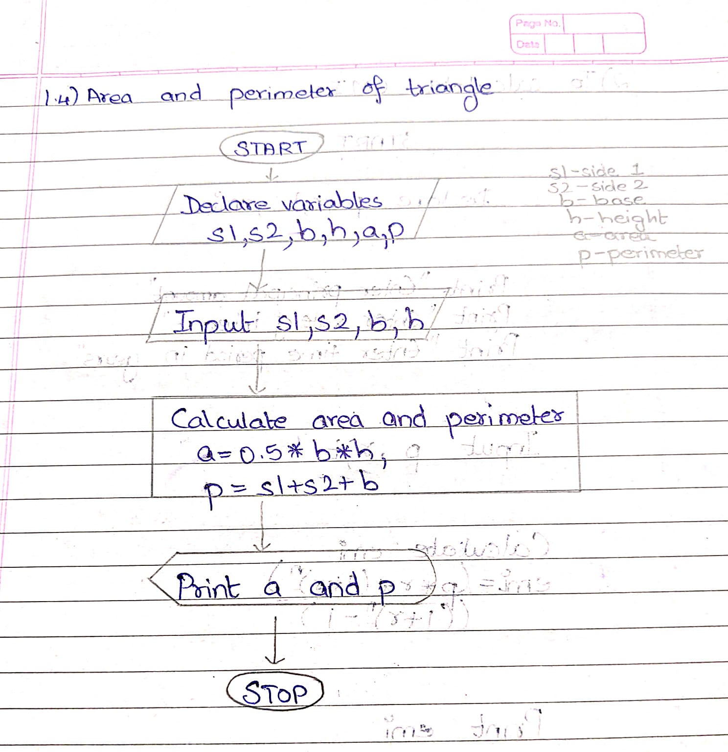

1.5 ] To calculate EMI :

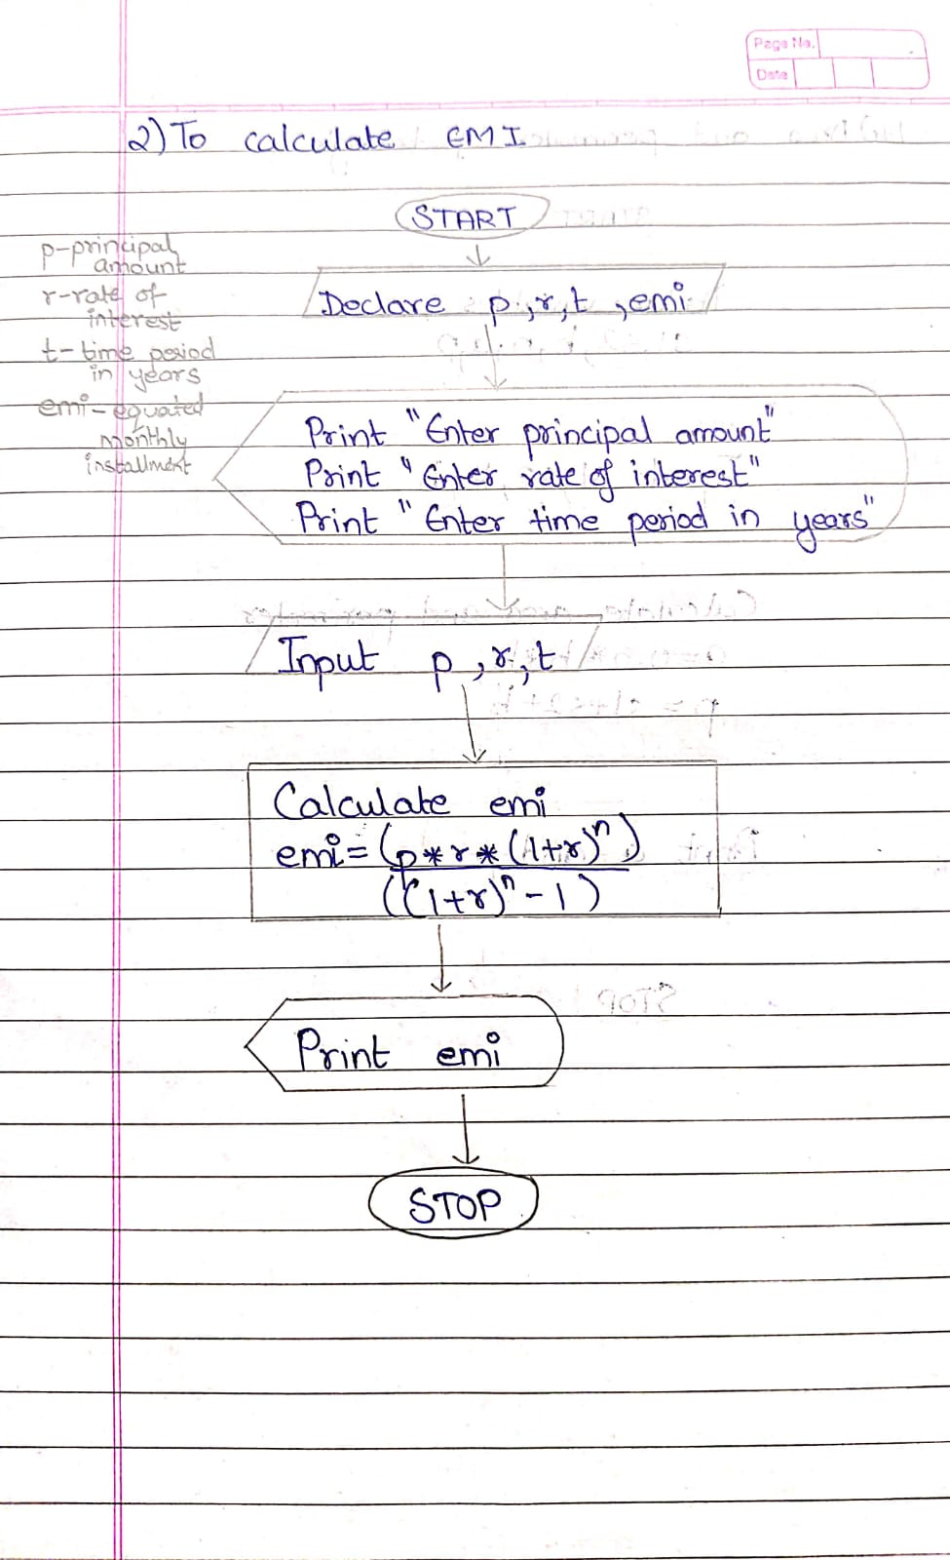

**Implementation details:**

#include <stdio.h>

main ()

// 1.1] area and circumference of circle

{

float r,a,p;

printf("Enter radius of circle:");

scanf("%f",&r);

a=3.14*r*r;

p=2*3.14*r;

printf("Area= %.2f",a);

printf("\nCircumference= %.2f",p);

}

//1.2] area and perimeter of rectangle

#include <stdio.h>

main ()

{

float l,b,a,p;

printf("Enter length of rectangle:");

scanf("%f",&l);

printf("Enter breadth of rectangle:");

scanf("%f",&b);

a=l*b;

p=2*(l+b);

printf("Area= %.2f",a);

printf("\nPerimeter= %.2f",p);

}

//1.3] area and perimeter of square

#include <stdio.h>

main ()

{

float s,a,p;

printf("Enter side of square:");

scanf("%f",&s);

a=s*s;

p=4*s;

printf("Area= %.2f",a);

printf("\nPerimeter= %.2f",p);

}

//1.4] area and perimeter of triangle

#include <stdio.h>

main ()

{

float b,h,s,s2,a,p;

printf("Enter base of triangle:");

scanf("%f",&b);

printf("Enter height of triangle:");

scanf("%f",&h);

printf("Enter side 1 of triangle:");

scanf("%f",&s);

printf("Enter side 2 of triangle:");

    scanf("%f",&s2);

    a=0.5*b*h;

    p=s+s2+b;

printf("Area= %.2f",a);

printf("\nPerimeter= %.2f",p);

}

//2] calculate emi

#include <stdio.h>

main ()

{

float pr,r,t,e;

printf("To calculate EMI (Equated Monthly Instalment) of loan amount:-\n");

printf("Enter the principal amount:");

scanf("%f",&pr);

printf("Enter the rate of interest:");

scanf("%f",&r);

printf("Enter the time period in a year:");

scanf("%f",&t);

r=r/(12*100);

t=t*12;

e=(pr*r*pow(1+r,t))/(pow(1+r,t)-1);

printf("EMI= %.2f",e);

}

**Output(s):**

* 1. **] CIRCLE**

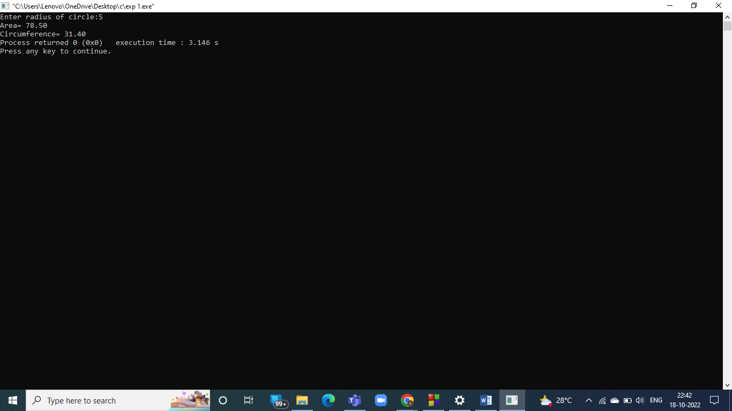

**1.2] RECTANGLE**

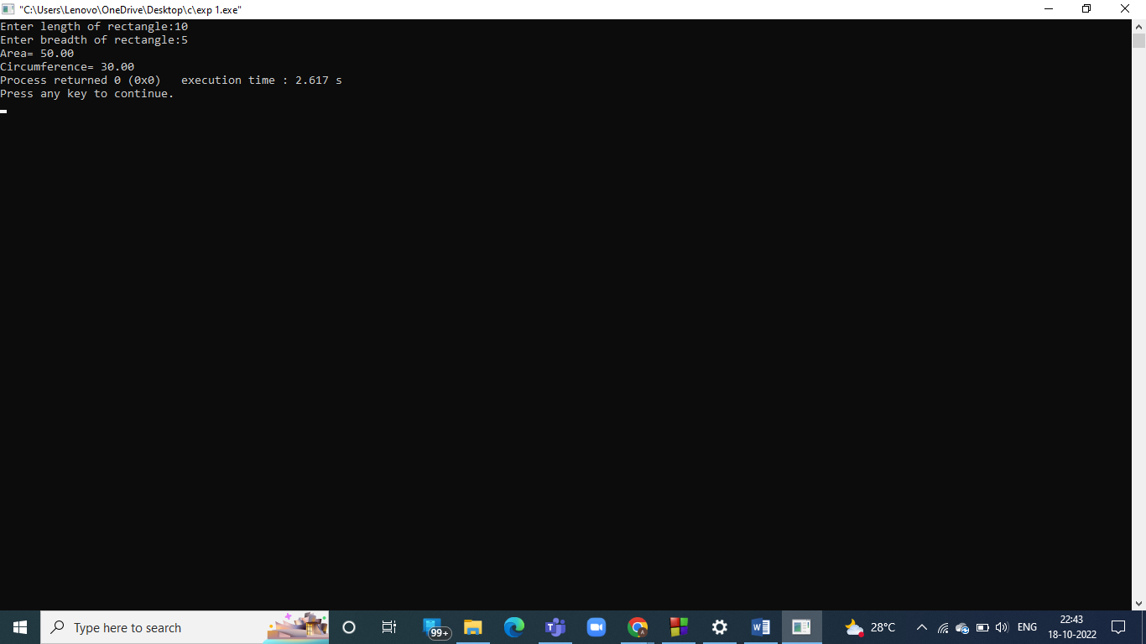

**1.3] SQUARE**

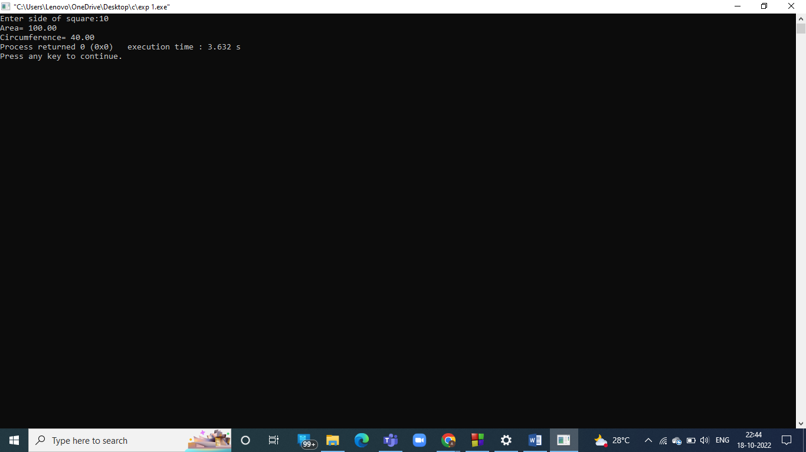

**1.4 ] TRIANGLE**

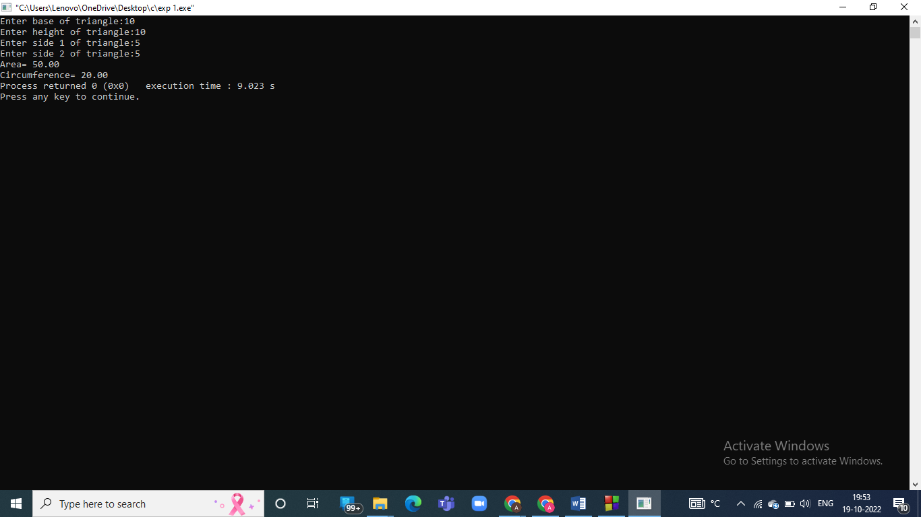

1. **] To calculate EMI**

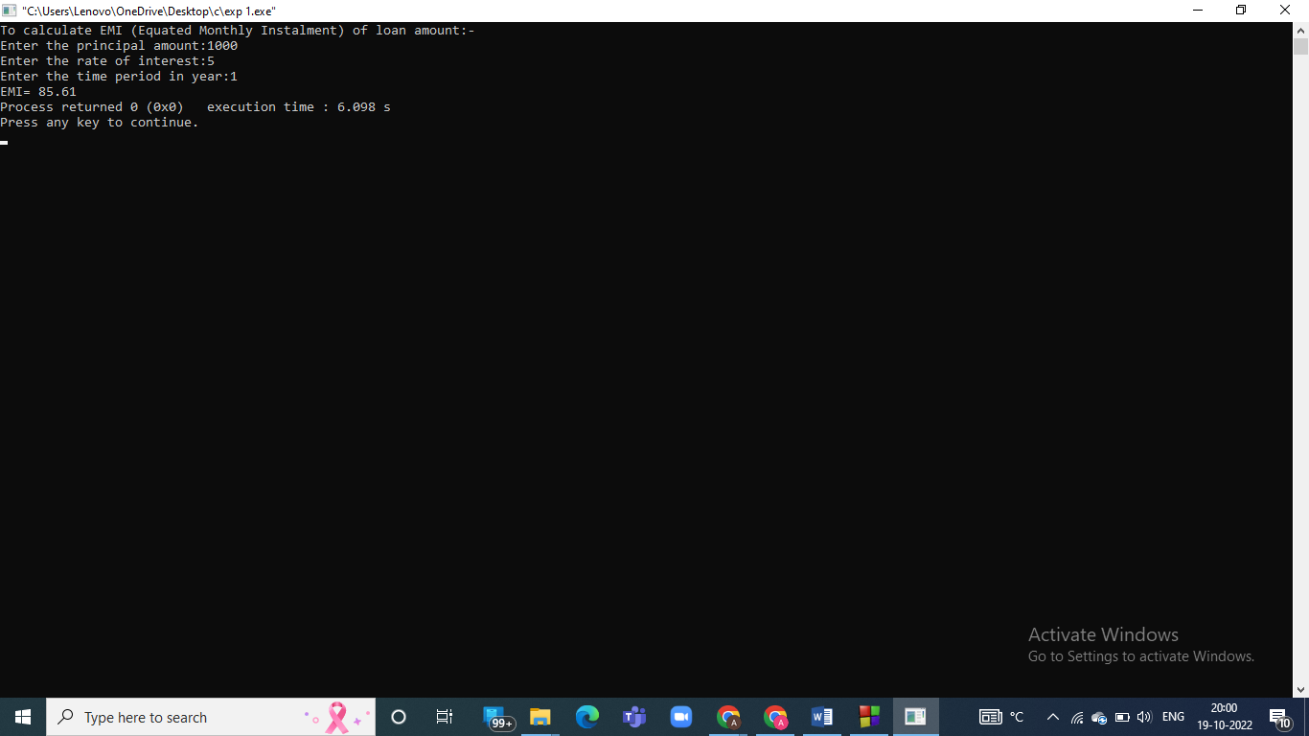

**Conclusion:**

We have learned how to use printf and scanf function, system variables .

**Post Lab Descriptive Questions**

1. **What are the basic data types in C?**
2. **What is a flowchart? What are the standard symbols used to draw a flowchart ? Explain in brief.**

1) Basic data types in C:

Integer

Double

Float

Character

Short

Long

2) A flowchart is a diagram that represents an algorithm . It is a diagrammatic respresentation which gives solution of a problem. Flowchart shows steps as boxes of other kind and their order is connected by arrows. It provides breakdown of essential steps in solving a problem.

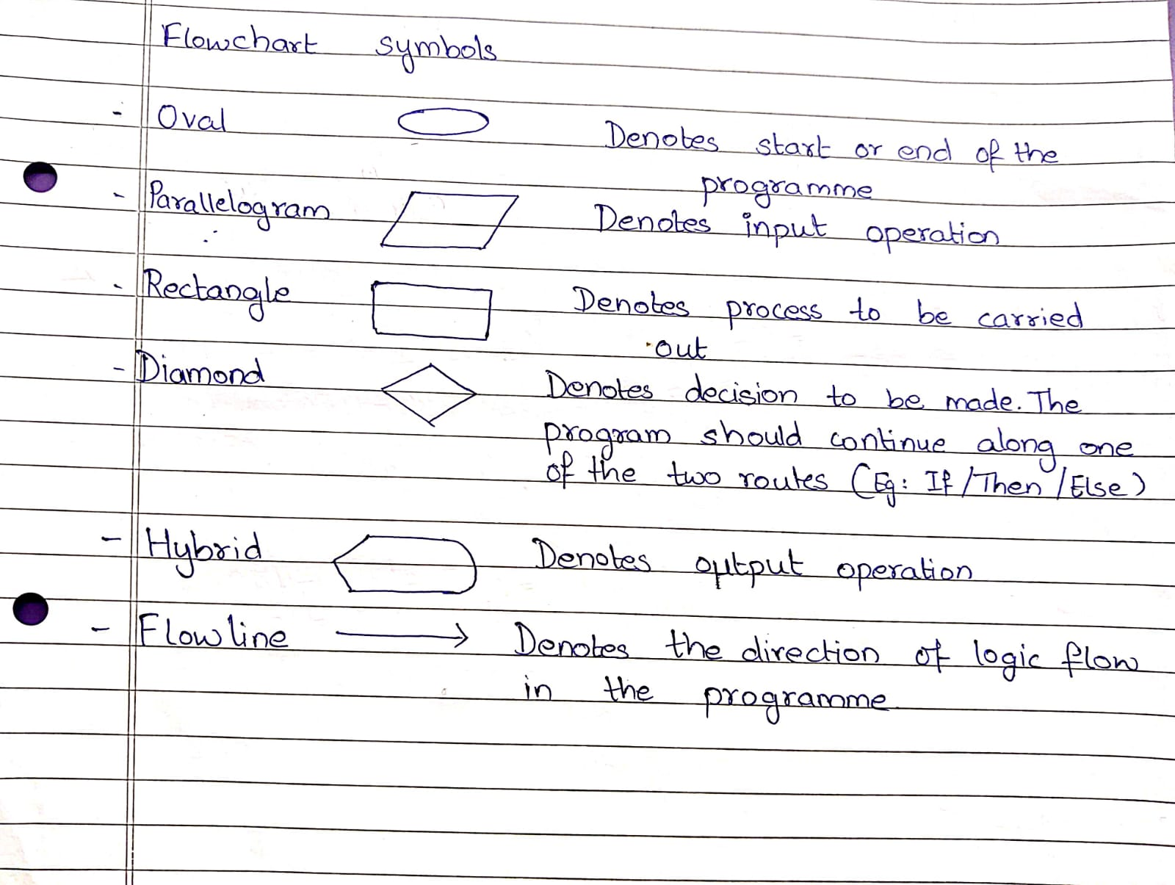

**Date: _____________ Signature of faculty in-charge**